Riverina Theatre Company Records

Charles Sturt University Regional Archives
Summer Scholarship Report
2009-2010
Sarah Ind

Riverina Theatre Company Records

INTRODUCTION
In 1997, the Riverina Theatre Company (RTC) deposited the bulk of their records to the Charles Sturt University (CSU) Regional Archives, ensuring the preservation of an important part of the Riverina’s cultural history. Extending for almost 25 linear metres, this large collection contained material from the company’s formation in 1976 and records produced during the following 20 years of its operation as one of the premier regional theatre companies in Australia. The diversity of RTC activities contributed to the accumulation of material including scripts, programmes, posters, photographs and video. Housed in 132 unsorted type 1 boxes, the arrangement and description of the RTC records provided a challenging and rewarding task for this Summer Research Scholarship.

THE RIVERINA THEATRE COMPANY
The inauspicious beginning of the Riverina Trucking Company, as the RTC was known until 1983, may not have inspired confidence as to the long term success of the theatre company. An opening production of the rock pantomime, Hamlet on Ice, relied on lights made from jam tins, a dimmer board bought from Coles and free tickets to attract an audience. Between 1976 and 1997, the company staged over 100 productions in their home town of Wagga Wagga, and toured regularly throughout the Riverina. Plays performed ranged from classics to commissions, with both experimental and traditional musical, drama and comedy productions. An emphasis on Australian content supported their aim of providing theatrical services and resources to the community and promoting regional theatre in Australia. School visits, workshops, play reading events and Theatre Games were also an important part of RTC activities, and enabled community involvement whilst providing employment and training opportunities. In 1986 the company joined the Riverina Murray Institute of Higher Education (now CSU) in the opening of the 250-seat Riverina Playhouse near the centre of Wagga Wagga. Alongside RMIHE student productions, the RTC used the venue to continue its successful presentation of a “feast of theatre” for local and supportive audiences.
ARRANGEMENT AND DESCRIPTION
On first being shown the RTC records my curiosity met with over 2000 manila folders of unknown content. Through initial handling and label perusal, the type and forms of information contained within became clearer, and the removal of all files from their boxes led to a tentative “piling” system, with similar or like items distinguished. The folders had a startling array of titles and labelling, which inspired the implementation of multiple tagged “miscellaneous” piles (containing virtually all the files) and potential categories. Items in other formats such as albums, videos, books and magazines were relegated to the sides of three large sorting bays.
Many of the folders were spine-labelled scripts, and these and other scripts formed another pile system on two sorting tables. The likely ease of alphabetically arranging these led to the employment of an “edges of the jigsaw” approach, whereby the easiest pieces of the “puzzle” could be completed first. Ordering the scripts revealed several arrangement complications: wrong titles (e.g. Who’s Afraid of Virginia Woolf was labelled “Fun and Games”), duplicates, loose scripts, untitled scripts, partial scripts, scripts with more than one title (e.g. The Life and Death of Jesse James / The Death and Life of Jesse James), and scripts that were in book form. After removing duplicates, inserting loose scripts into folders and alphabetically ordering them all, a “List of Scripts” was compiled, but this was soon to be overwritten as further sorting revealed many that had escaped notice. The final listing revealed a total of 350 scripts, which in their 20 boxes comprised almost a quarter of the end total number of boxes.
Shifting, stacking, sorting and restacking also revealed many numbered folders. The hope of uncovering an existing order within the “miscellaneous” files inspired me to sift through and separate almost 200 files, but closer inspection of their contents revealed a random allocation of numbers to files of all kinds (and their curious commencement at the number 112). A search for other potential order systems led to the development of new stacks such as “files with black marker titles”, “big lots of paper tied with string”, “press?” and “things not in folders”. The numbered and otherwise distinctive files, however, ended up being later dispersed through the other categories, along with arbitrary chronological distinctions between different eras of the company.
Another category that grew to a substantial stack at this stage was termed “production files”, as many folders had strange or confusing titles that were reminiscent of the sorted scripts: Boss of the Pool, Lipstick Dreams, Upside Down at the Bottom of the World. Folders labelled “Writers” could either refer to authors RTC was in correspondence with or were related to the play, Writers. Ambitiously alphabetizing these files saw a repeat of my previous error of overlooking relevant files, and the ensuing days located even more production files than I had initially listed. Other complications occurred with the realisation that alternate or shorthand titles were frequently used in labelling. Summer of the Seventeenth Doll files were often labelled “The Doll” (much easier to write) and the acronyms BBT, BoMB and OOS turned out to be Beach Blanket Tempest, Boys’ Own McBeth and On Our Selection.

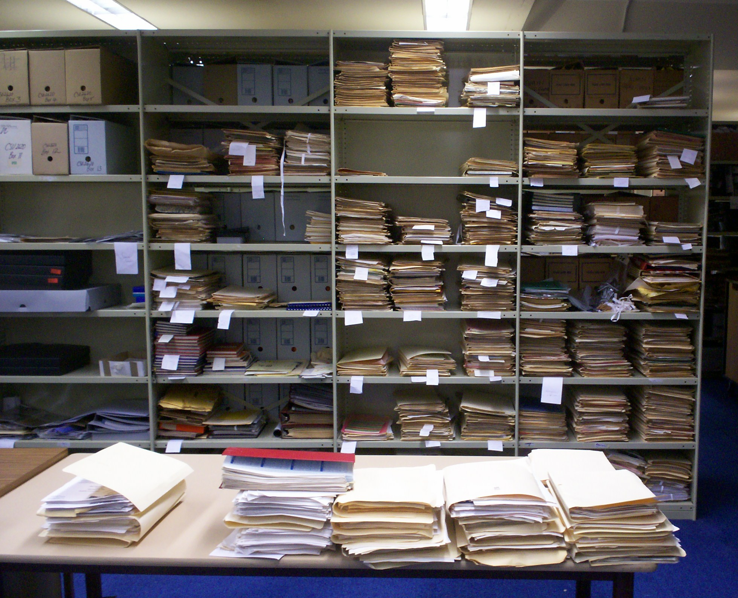
Signs of arrangement.

At this stage of the task the importance of investigating inside the manila folders became clear, and not taking external labelling as it was written (or typed/stuck on/scrawled) was helpful; folders had accidently made their way inside other folders, some had incongruous or incomprehensible labelling, and vagabond documents needed to be re-homed. Determining what was in all the miscellaneous files was the next step. Categories became clearer, each sorting to distribute files to more specific piles generated new tags, and eventually there was a respectably low “miscellaneous” pile and numerous labelled categories and piles. Many of the less common files made their way into the “Subject Files” series in the description, including the obscure “Kalamazoo Register” (unable to be deciphered) and maps showing the company’s travel routes through the Riverina region.
An introduction to the archival art of disposal furthered my enthusiasm for completing the project, and amongst the first items to be removed from the collection were two boxes of tickets and stubs and a large pile of receipts and invoices. In accordance with CSU Regional Archives normal administrative practice, ephemeral or facilitative records not considered to be of continuing value, as well as certain types of financial records may be disposed of. The duplication of many documents in the RTC collection required sifting through each folder and contributed to the disposal of 33 boxes throughout this process. Other items disposed of included promotional material from other organisations, magazines, booklets, some low-level correspondence and several disintegrating plastic sheets that littered the sorting tables with flakes like insect wings. More experience and familiarity with the Archives’ disposal practice would likely have led to the removal of much more material from this collection; many files had dubious continuing value, but I was not always confident of asserting this.
Arranging the files into categories provided the option of arranging the files within the categories. After exercising my proficiency at knowing the alphabet, I found that many categories were better sorted chronologically, but that there were many more days and months and years than there were alphabet letters, and that there were many different ways the files had been dated, such as: not at all, with a year/s that didn’t match what was contained within, or with a range of years but with varying emphasis (e.g. mostly 1978 but with one document from 1992). I adopted the technique of sorting the files using the first date contained, but where this was difficult I shuffled the files and hoped they sorted themselves, which could be termed a “rough sort”. Clipping small tags to the front of each file with dates and subject made later arrangement simpler. Virtually all my exploration through the RTC records was conducted with little probing into the complexities of the theatre company’s operation, but much study of the strata of successive filing systems and administrative tendencies.
The task of removing all metal objects (pins, paperclips, bulldog clips, binder clips, clasps and staples) from the documents initially seemed daunting, but with the assistance of an awl-type staple-remover some small mountains of metal were built on the table. After several days of this activity I could rest with the knowledge that most of the metal was gone. In its wake lay a residue of rust coloured stains on documents, and many holes and indents, but also the hopeful prevention of more damage. Other archival concerns were the many faxed documents on thermal paper and carbon copied coloured pages, both of which have relatively short life spans. Although the RTC had made copies of some faxed documents, there were many that hadn’t been copied and not all of these were photocopied during this project.

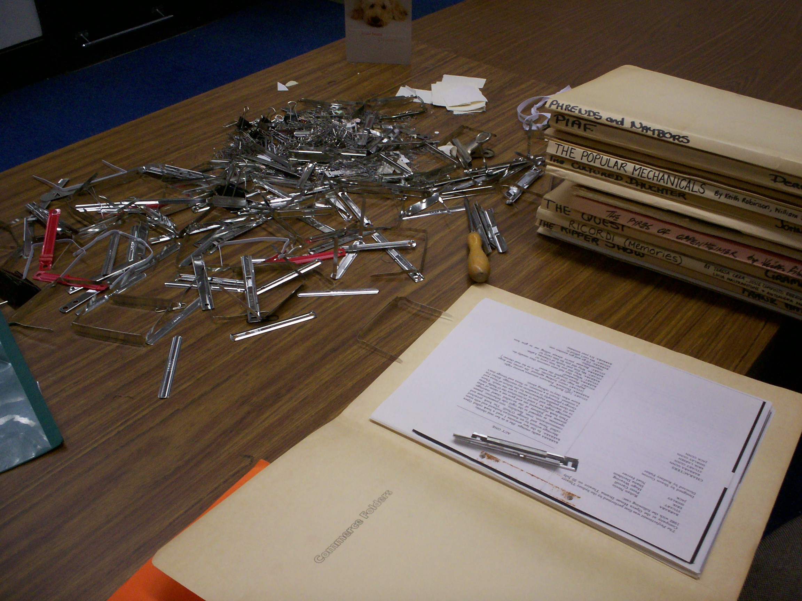
Metal removal.

The RTC records included a few thousand production photographs and images of the company, but knowing which production the photographs were from was not always possible, and the many miscellaneous photos were divided into those that had names printed on the reverse, and those unable to be identified. Many photos had been stored and displayed in self adhesive albums which had caused them to become “stuck” and the images needed to be carefully removed to prevent damage before being transferred into archival sheets.
The process of description involved compiling a list of main categories or “List of Series Lists”, which formed a sequence in which smaller series could be incorporated. Several groups of files, such as those relating to the same production, were secured together, and numbering each file with a sharpened pencil was a highlight of the process. Working systematically through the various piles on the shelving saw them disappear back into boxes, with the end result of a lengthy list and many empty boxes to be packed down. The completed listing of the RTC records contains 43 series and 1476 items, and is now stored in 79 type 1 boxes, 21 photograph albums and one map drawer.

CONCLUSION
After 30 years of entertaining audiences in Wagga Wagga and surrounding areas, the Riverina Theatre Company went into voluntary liquidation in March 2009. A failure to secure competitive Australia Council funding, and the limited success of their previous two productions meant the company was unable to continue. It would be interesting to observe records from the later period of the theatre company’s history (1997 – 2009) and bear witness to the progression of electronic files and changing nature of physical documents. The early years saw record keeping practices that embraced typewriter technology, telegrams, foolscap, vast arrays of scrap and ephemeral note taking, and a multiplicity of now vintage stationary supplies. Although the records from their final twelve years are not held by the CSU Regional Archives, it can be assumed that many would reveal a dependence on the electronic creation and maintenance of documents. Arranging and describing the material contained in this collection has provided an opportunity to participate in the preservation of significant cultural records, and I have gained much experience and insight into archival processing.

RW1780, CSU Regional Archives. Riverina Theatre Company. (1986). The First Ten Years.
Grimson, K. (2009, March 19). Curtain falls on theatre company. The Daily Advertiser.

